**Where to set up my café**

1. **Introduction**

**Background**

In Thailand, there is exponentially growing demand for coffee drinks in recent years. According to Euromonitor, the coffee consumption in Thailand ranked 41th out of all countries. In addition, the average age of coffee consumers in Thailand edged down to 16-18 years old from 23 years old in the past years. These numbers confirm that there is still high demand for coffee and coffee shop business is still a highly profitable business in Thailand these days.

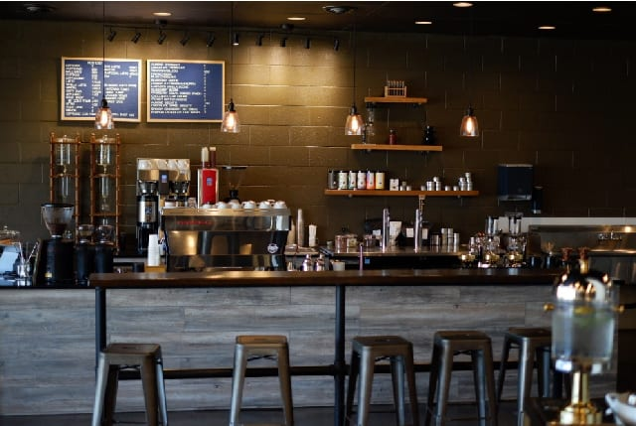

**Business plan**

With high demand for coffee in Thailand, especially among Thai teenagers and students, I plan to open my own cafe and consider that my target group will be university students. My cafe accordingly should be in a spot that can best attract this consumer group.

So, I decide to set up my cafe near Chulalongkorn University, one of the most famous and largest universities in my city. After planning, I plan that my cafe needs to be within a one-kilometer range around the University.

1. **Data and Method**

Data used in this project will be imported from Foursquare using Foursquare API. The data needed will be in the locations (latitude and longitude) of cafes around Chulalongkorn University within one-kilometer distance.

The data imported will be cleaned to have cafes’ names, latitudes, longitudes. Next, all the locations retrieved will be plotted on a map with their names and locations.

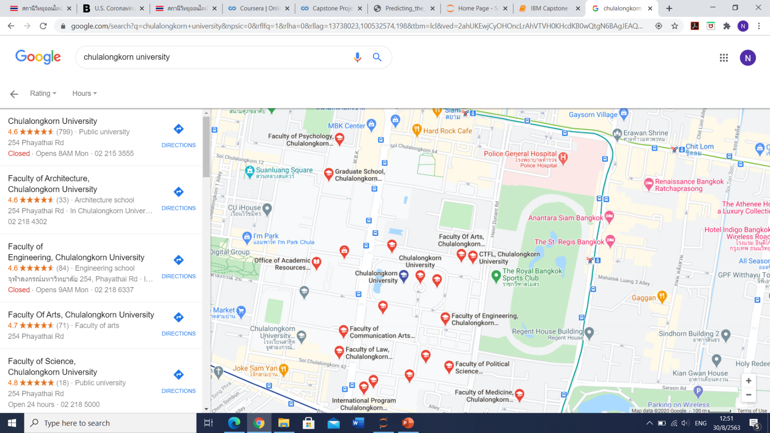

1. **Result**

After retrieving data, we found that there are about 30 cafes within a one-kilometer range around Chulalongkorn University.

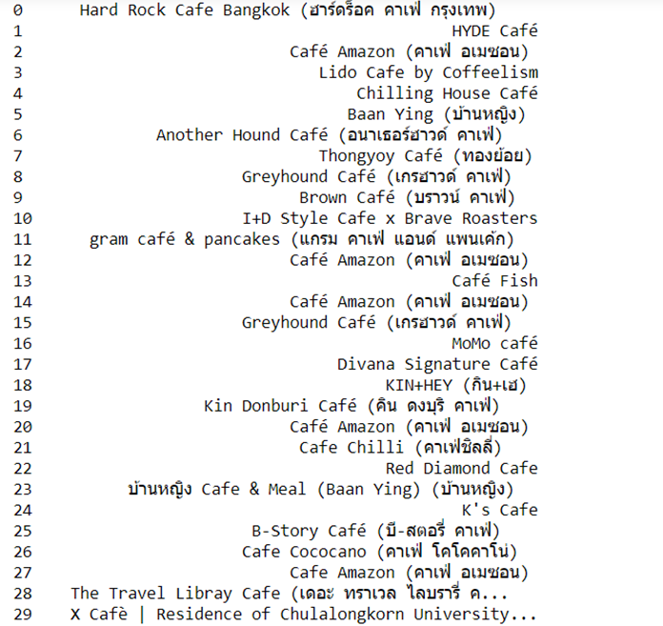

Next, we plotted all the cafes with their locations on a map. We found that most of the cafes (blue circles) around Chulalongkorn University (red circle) are highly populated on the north side of the University.

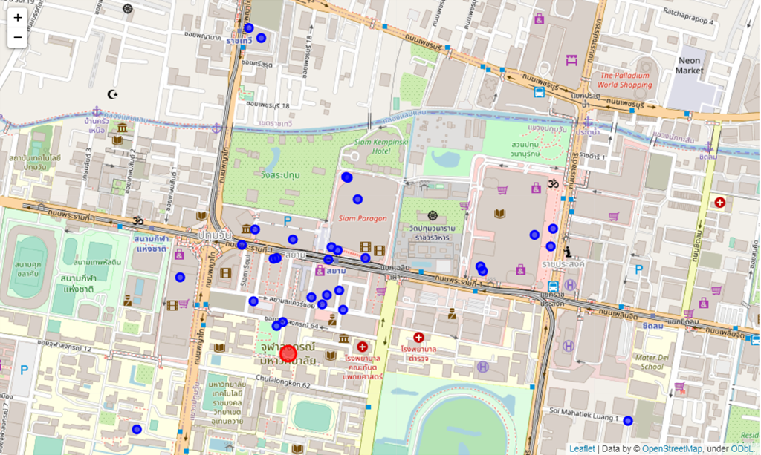

1. **Discussion**

As we can see in the map, most of the cafes around Chulalongkorn University are highly populated on the north side of the University. So, it can be assumed that there will likely be a competitive market in that area. Given that assumption, it will likely be more profitable to set up my new cafe on the south or east side of the University

Accordingly, my plan is to open my new cafe somewhere along Henri Street (the yellow line on the right-hand side of the University) and this is also because this street is a main street for most students to walk or commute to the University.